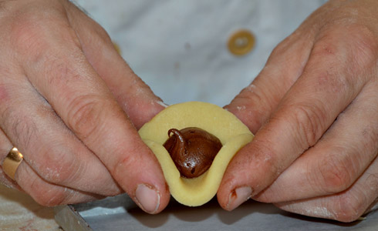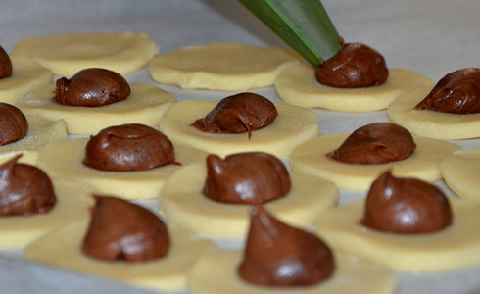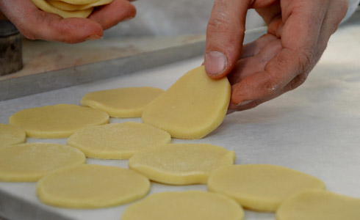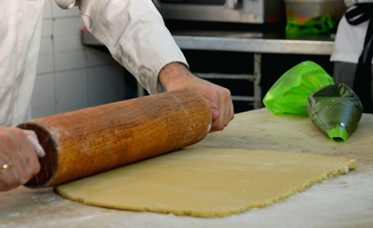

[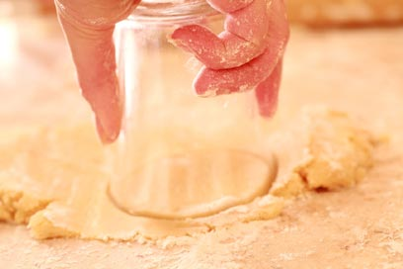](http://www.google.co.il/url?sa=i&rct=j&q=&esrc=s&frm=1&source=images&cd=&cad=rja&uact=8&ved=0CAcQjRw&url=http://www.ynet.co.il/articles/0,7340,L-3852080,00.html&ei=IG_sVKrkCpDUatP4gKgH&bvm=bv.86475890,d.d2s&psig=AFQjCNGJT6kQLp5RoVVeSwDalPIfRtb6OQ&ust=1424867328670072)  
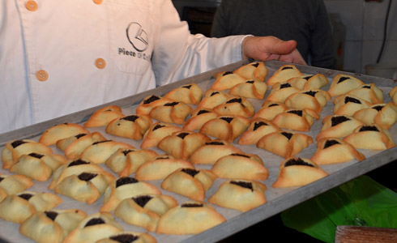

[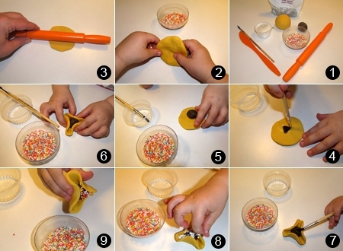](http://www.google.co.il/url?sa=i&rct=j&q=&esrc=s&frm=1&source=images&cd=&cad=rja&uact=8&ved=0CAcQjRw&url=http://food.nana10.co.il/Article/?ArticleID%3D881533&ei=n27sVJeQCtPlao-OgbgN&bvm=bv.86475890,d.d2s&psig=AFQjCNGJT6kQLp5RoVVeSwDalPIfRtb6OQ&ust=1424867328670072)

[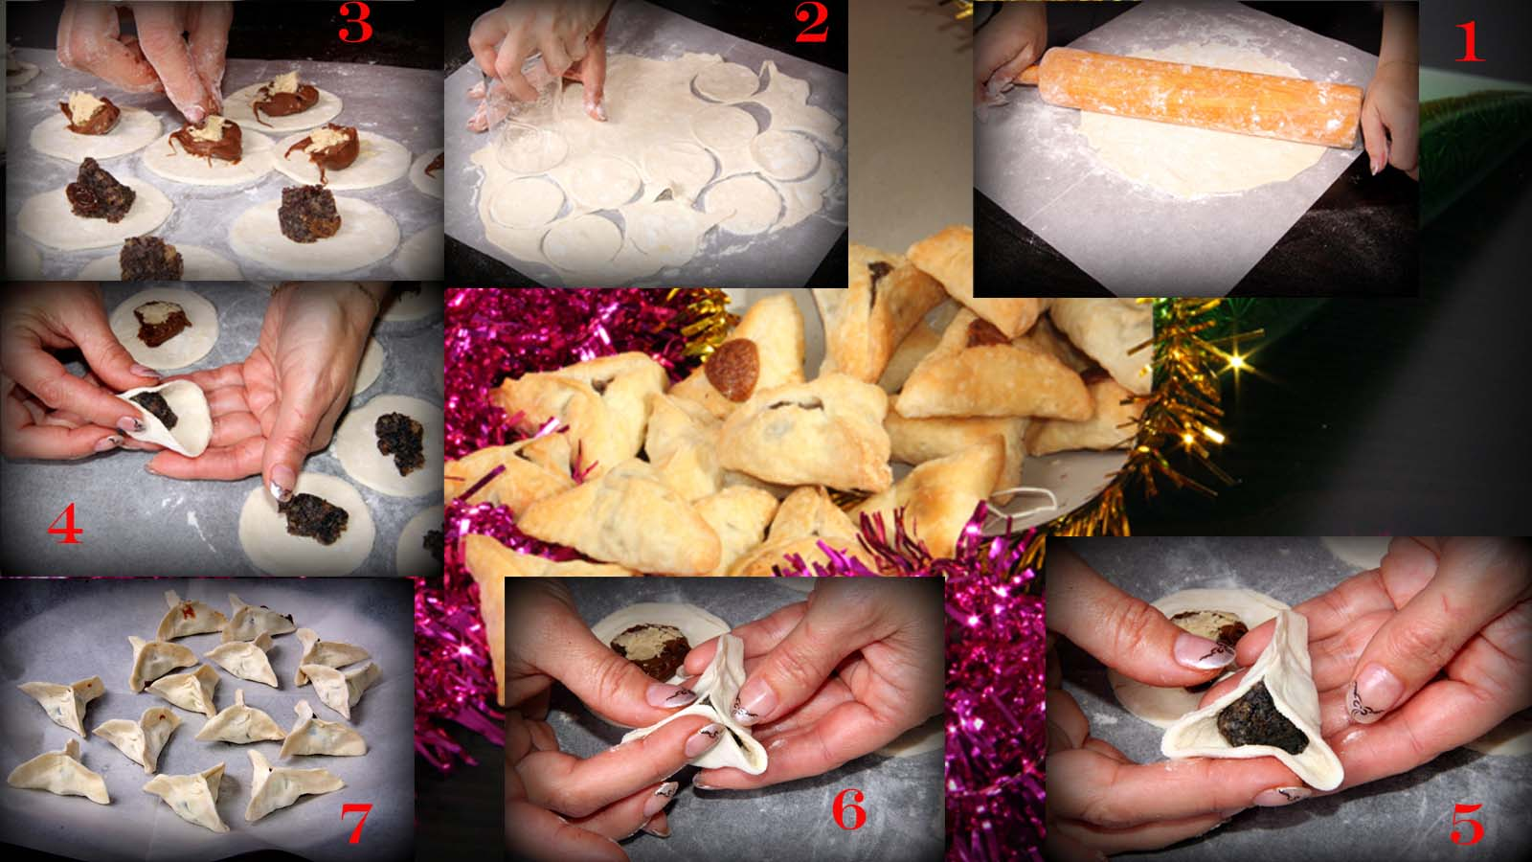](http://www.chef-bekef.co.il/?page=oznyhaman)